Java Object-Oriented Programming Experimental Report
NO: Experiment 6 Experiment name：Object-Oriented Design
Student ID | 1607052230 | Name | 邱冠霖 | Class |  | 16软工1班
Location | 1-218 | Teacher | 唐朝辉 | Time |  | 20180413
1.Experimental purposes and requirements
1.1 Parameter Passing
1.2 Overloading
1.3 Static Variables and Methods
1.4 GUI Layouts
2.Experimental equipment (environment) and requirements
2.1 Eclipse
2.2 Window XP
3.Lab Exercises(Please see Lab Manual)
3.1Changing People(Choose to do)
3.2 Using the Comparable Interface(Choose to do)
3.3 A Modified MiniQuiz Class(Choose to do)
3.4 A Flexible Account Class
3.5 Modifying the Coin Class(Choose to do)
3.6 Opening and Closing Accounts
3.7 Counting Transactions(Choose to do)
3.8 Transfering Funds(Choose to do)
3.9 Random Walks(Choose to do)
3.10Telephone Keypad
4.Experimental results and data processing

5.Analysis and discussion

6.Teacher Reviews  Signature：  Date： |  |  |  |  | Score:

Experimental Report List
1 Changing People
1) Source code list

2) Results data processing

3) Answer questions

4)Error Analysis and Discussion

4 A Flexible Account Class
1) Source code list

package chapter06;
import java.util.Scanner;
/**
* @Description:
* @Author: QiuGuanLin
* @Date: 2018/4/8 10:14
*/
public class TestAccount {
public static void main(String[] args) {
String name;
double balance;
long acctNum;
Account acct;
Scanner scan = new Scanner(System.in);
System.out.println("Enter account holder's first name");
name = scan.next();
acct = new Account(name);
System.out.println("Account for " + name + ":");
System.out.println(acct);
System.out.println("\nEnter initial balance");
balance = scan.nextDouble();
acct = new Account(balance, name);
System.out.println("Account for " + name + ":");
System.out.println(acct);
System.out.println("\nEnter account number");
acctNum = scan.nextLong();
acct = new Account(balance, name, acctNum);
System.out.println("Account for " + name + ":");
System.out.println(acct);
System.out.print("\nDepositing 100 into account, balance is now ");
acct.deposit(100);
System.out.println(acct.getBalance());
System.out.print("\nWithdrawing $25, balance is now ");
acct.withdraw(25);
System.out.println(acct.getBalance());
System.out.print("\nWithdrawing $25 with $2 fee, balance is now ");
acct.withdraw(25, 2);
System.out.println(acct.getBalance());
System.out.println("\nBye!");
}
}

package chapter06;
import java.util.Random;
/**
* @Description:
* @Author: QiuGuanLin
* @Date: 2018/4/8 10:13
*/
public class Account {
private double balance;
private String name;
private long acctNum;
//----------------------------------------------
//Constructor -- initializes balance, owner, and account number
//----------------------------------------------
public Account(double initBal, String owner, long number) {
balance = initBal;
name = owner;
acctNum = number;
}
public Account(double initBal, String owner) {
balance = initBal;
name = owner;
acctNum = (int) (Math.random() * 100);
//生成0~100的随机数
}
public Account(String owner) {
balance = 0;
name = owner;
acctNum = (int) (Math.random() * 100);
//生成0~100的随机数
}
//----------------------------------------------
// Checks to see if balance is sufficient for withdrawal.
// If so, decrements balance by amount; if not, prints message.
//----------------------------------------------
public void withdraw(double amount) {
if (balance >= amount) {
balance -= amount;
} else {
System.out.println("Insufficient funds");
}
}
public void withdraw(double amount, double fee) {
if (balance >= amount + fee) {
balance -= amount;
balance -= fee;
} else {
System.out.println("Insufficient funds");
}
}
//----------------------------------------------
// Adds deposit amount to balance.
//----------------------------------------------
public void deposit(double amount) {
balance += amount;
}
//----------------------------------------------
// Returns balance.
//----------------------------------------------
public double getBalance() {
return balance;
}
//----------------------------------------------
// Returns a string containing the name, account number, and balance.
//----------------------------------------------
@Override
public String toString() {
return "Name:" + name +
"\nAccount Number: " + acctNum +
"\nBalance: " + balance;
}
}

2) Results data processing

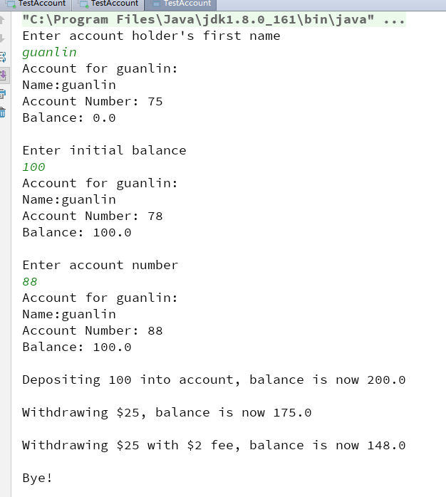
3) Answer questions

4)Error Analysis and Discussion

6 Opening and Closing Accounts
1) Source code list
package chapter06;
import java.util.Scanner;
/**
* @Description: 实验六第6题
* @Author: QiuGuanLin
* @Date: 2018/4/8 10:30
*/
public class TestAccounts1 {
public static void main(String[] args) {
Account1 testAcct;
Scanner scan = new Scanner(System.in);
System.out.println("How many accounts would you like to create?");
int num = scan.nextInt();
for (int i = 1; i <= num; i++) {
testAcct = new Account1(100, "Name" + i);
System.out.println("\nCreated account " + testAcct);
System.out.println("Now there are " + Account1.getNumAccounts() + " accounts");
}
Account1 a1 = null;
Account1 a2 = null;
Account1 a3 = null;
Account1 a4 = null;
a1 = new Account1(100, "name1");
System.out.println(a1.printf());
a2 = new Account1(100, "name2");
System.out.println(a2.printf());
a3 = new Account1(100, "name2");
System.out.println(a3.printf());
a1.close();
System.out.println("第一个账户关闭成功");
a4 = Account1.consolidate(a2, a3);
System.out.println(a4.printf());
System.out.println("第二三个账户合并成功");
}
}

package chapter06;
/**
* @Description:
* @Author: QiuGuanLin
* @Date: 2018/4/8 10:31
*/
public class Account1 {
private double balance;
private String name;
private long acctNum;
private static long numAccounts;
// 银行需要追踪当前的账户数
static {
numAccounts = 0;
}
//----------------------------------------------
//Constructor -- initializes balance, owner, and account number
//----------------------------------------------
public Account1(double initBal, String owner, long number) {
balance = initBal;
name = owner;
acctNum = number;
numAccounts += 1;
}
public Account1(double initBal, String owner) {
balance = initBal;
name = owner;
acctNum = (int) (Math.random() * 10000);
//生成0~10000的随机数
numAccounts += 1;
}
public Account1(String owner) {
balance = 0;
name = owner;
acctNum = (int) (Math.random() * 10000);
//生成0~100的随机数
numAccounts += 1;
}
//----------------------------------------------
// Checks to see if balance is sufficient for withdrawal.
// If so, decrements balance by amount; if not, prints message.
//----------------------------------------------
public void withdraw(double amount) {
if (balance >= amount) {
balance -= amount;
} else {
System.out.println("Insufficient funds");
}
}
public void withdraw(double amount, double fee) {
if (balance >= amount + fee) {
balance -= amount;
balance -= fee;
} else {
System.out.println("Insufficient funds");
}
}
//----------------------------------------------
// Adds deposit amount to balance.
//----------------------------------------------
public void deposit(double amount) {
balance += amount;
}
//----------------------------------------------
// Returns balance.
//----------------------------------------------
public double getBalance() {
return balance;
}
public static long getNumAccounts() {
return numAccounts;
}
public String getName() {
return name;
}
public void setName(String name) {
this.name = name;
}
public long getAcctNum() {
return acctNum;
}
public void setAcctNum(long acctNum) {
this.acctNum = acctNum;
}
void close() {
name = "CLOSED";
balance = 0;
numAccounts -= 1;
}
// 创建一个新的账户（新账户balance的值为acct1 和 acct2的balance之和，
// 同时关闭acct1 和 acct2）并返回新创建的账户对象
public static Account1 consolidate(Account1 acct1, Account1 acct2) {
Account1 newacct = null;
if (acct1.getName().equals(acct2.getName()) && acct1.getAcctNum() != acct2.getAcctNum()) {
try {
newacct = new Account1(acct1.getBalance() + acct2.getBalance(), acct1.getName());
acct1.close();
acct2.close();
} catch (Exception e) {
System.out.println(e);
}
} else {
System.out.println("姓名或者账号不合规范");
}
return newacct;
}
@Override
public String toString() {
return "Name:" + name +
"\nAccount Number: " + acctNum +
"\nBalance: " + balance;
}
public String printf() {
return "Account1{" +
"balance=" + balance +
", name='" + name + '\'' +
", acctNum=" + acctNum +
'}';
}
}

2) Results data processing
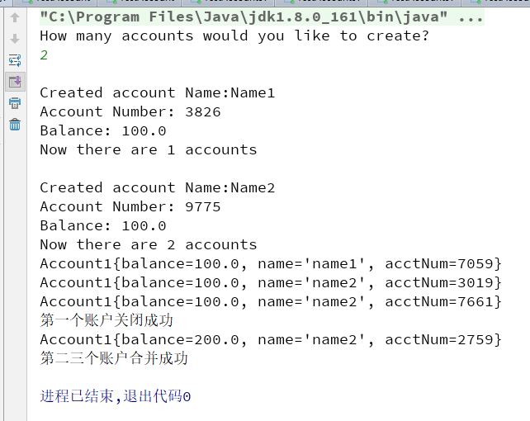

3) Answer questions

4)Error Analysis and Discussion

10 Telephone Keypad
1) Source code list

package chapter06;
import javax.swing.*;
/**
* @Description:
* @Author: QiuGuanLin
* @Date: 2018/4/8 11:19
*/
public class Telephone {
public static void main(String[] args) {
JFrame frame = new JFrame("Telephone");
frame.setDefaultCloseOperation(JFrame.EXIT_ON_CLOSE);
frame.getContentPane().add(new TelephonePanel());
frame.setSize(400, 400);
// frame.pack();
frame.setVisible(true);
}
}

package chapter06;
import javax.swing.*;
import javax.swing.border.BevelBorder;
import javax.swing.plaf.basic.BasicOptionPaneUI;
import java.awt.*;
/**
* @Description:
* @Author: QiuGuanLin
* @Date: 2018/4/8 11:20
*/
public class TelephonePanel extends JPanel {
private JButton[] button;
JPanel keypadPanel;
public TelephonePanel() {
//set BorderLayout for this panel
this.setLayout(new BorderLayout());
//create a JLabel with "Your Telephone" title
JLabel NameJLabel = new JLabel("My Telephone");
JPanel title = new JPanel();
title.add(NameJLabel);
//add title label to north of this panel
this.add(title, BorderLayout.NORTH);
//create panel to hold keypad and give it a 4x3 GridLayout
keypadPanel = new JPanel(new GridLayout(4, 3));
//add buttons representing keys to key panel
String name[] = {"1", "2", "3", "4", "5", "6", "7", "8", "9", "*", "0", "#"};
button = new JButton[name.length];
for (int i = 0; i < name.length; i++) {
button[i] = new JButton(name[i]);
button[i].setBorder(BorderFactory.createBevelBorder(BevelBorder.RAISED));
button[i].setCursor(Cursor.getPredefinedCursor(Cursor.HAND_CURSOR));
button[i].setPreferredSize(new Dimension(5, 35));
// button[i].addActionListener();
keypadPanel.add(button[i]);
}
//add key panel to center of this panel
this.add(keypadPanel, BorderLayout.CENTER);
}
}

2) Results data processing
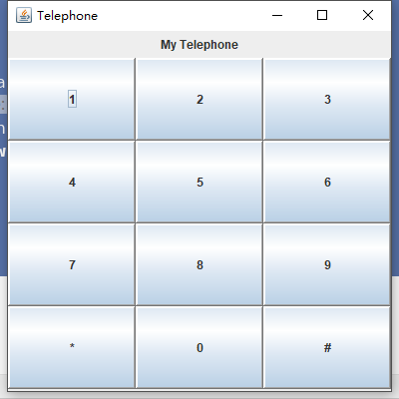

3) Answer questions

4)Error Analysis and Discussion

1 Changing People
1) Source code list

2) Results data processing

3) Answer questions

4)Error Analysis and Discussion

